Date: 21 June 2024

Maintenance and repair work on passenger vehicles and lorries

Powerful, safe, precise and gentle – Halder soft-face mallets for automotive professionals
BLACKCRAFT, SUPERCRAFT, SIMPLEX – the right solution for every task
Changing stuck wheels and bearings, body work, inserting transmission parts, positioning bolts, driving in shaft seals, freeing lower ball joints and more – workers in an automotive workshop often have to go at it hammer and tongs. Erwin Halder KG always has the hammer solution that is most suitable to ensure that every task is accomplished with the greatest ease possible. Whether it is a BLACKCRAFT, SUPERCRAFT or SIMPLEX – Halder soft-face mallets have come through in a myriad of repair and maintenance work applications.
Whether the car really is every German’s darling is debatable. What is certain, however, is that the automotive workshop is the only trusted authority when the need for maintenance and repair work arises. Aside from skilled specialists, the successful completion of the various work tasks on passenger cars, lorries and other commercial vehicles calls for the right workshop equipment. Whether they are working on the transmission or engine block, changing wheels or loosening plastic panels – only those who have the right tool at hand for every task will confidently master the stressful everyday life at a workshop for passenger and commercial vehicles and finish every job to the complete satisfaction of their demanding customers. Always the right amount of power for the perfect hit: Halder supplies a variety of soft-face mallets for different tasks.

Changing stuck tires
Stuck rims can turn into a time-consuming nuisance – especially in the spring and autumn when the usual load turns into a seemingly insurmountable demand for tire changes. The fully encased non-rebound BLACKCRAFT mallet from Halder solves this problem quickly – in the truest sense of the word – and in a way that is gentle on the rim – even on aluminium rims. Volker Gernth, Sales Director Hand Tools at Erwin Halder KG, explains why that is: “First of all, the polyurethane coating protects the sensitive rims from damage – and the hammer from corrosion. What is more, the coating also prevents sparks in the event if mis-strikes and keeps vibrations at a minimum. Secondly, the hammer is capable of delivering extremely powerful strikes thanks to its high head weight, the short handle, and the shot filling in the hammer head. “Since the energy of the shot filling is transferred to the contact surface with a slight delay, the impact energy is utilised with perfect efficiency.” What is more, the BLACKCRAFT allows for work with greatly improved safety, reduced strain on the joints and greater noise-dampening when compared to ordinary steel hammers. The soft-face mallet is available with diameters from 40 to 60 mm.

Those in need of greater power, for example for loosening lorry wheels, will find the right solution in the non-rebound SUPERCRAFT sledge hammer with nylon inserts and a total weight of 4,410 g.

Full impact even with oil-smeared hands
What car mechanic is not familiar with this issue? Working with hands covered in oil and grease. Regardless, the tools must not slip from your fingers. The ideal solution for powerful repair work with high impact power is the SUPERCRAFT soft-face mallet with break-proof 3-component handle. It will always stay securely in your hand. The reason: The flexible fibreglass core is coated with ergonomically shaped polypropylene and a non-slip elastomer layer. For example, shaft seals can be hammered in with great power and a secure grip – even if your fingers are not completely clean.
As with the BLACKCRAFT, the shot filling makes it possible to deliver exceedingly powerful strikes with the SUPERCRAFT. Another key asset are the exchangeable inserts made of special nylon. The material is hard, very wear-resistant and break-proof. As it will never splinter – even if used for forceful strikes on a hard edge, it is ideal for the assembly of sharp-edged workpieces and straightening work – with maximum safety at work. Its high-quality robot-welded joints also make the SUPERCRAFT strong enough to withstand extreme loads. Halder offers the version of the soft-face mallet with the 3-component handle with diameters of 40 mm, 50 mm and 60 mm.

Clever 2-in-1 solution for different tasks
The SIMPLEX soft-face mallet with the insert combination of copper and soft metal offers two hammers in one and makes it a cinch to free lower ball joints with targeted force. This means that one handle lets automotive mechanics have both the conventional copper and the lead hammer at hand. Even though it is the hardest impact insert in the SIMPLEX range and allows for exceptionally high impact forces, the copper insert is more gentle than a steel hammer. The soft metal insert made of aluminium is heat-resistant and slightly softer than the copper insert.
The reinforced cast steel housing lends this SIMPLEX variant great stability and enables it to deliver powerful strikes – not least thanks to its increased weight. The ergonomically shaped fibre glass handle contours perfectly to your hand and will not slip. Better still, it is insensitive to moisture – perfect for the workshop environment. “The combination of copper and soft metal insert plus fibreglass handle paired with the reinforced cast steel housing makes the SIMPLEX one of the hardest and most stable soft-face mallets as well as an ideal choice for extremely hard strikes. It can thus be used, for example, to release seized joints in confined spaces with just a few well-aimed strikes,” adds Volker Gernth.
In line with the smart SIMPLEX principle, all components are replaceable and can be retrofitted. This translates to savings in both money and resources.

Perfect combinations for automotive work
Whether for professional workshops or private tinkerers – the two different promotional boxes from Halder are perfect sets for different tasks: Besides the BLACKCRAFT mallet for powerful, yet material-friendly work, the BLACKCRAFT Promotional Box Automotive also contains the magnetic holder from Halder. Thanks to the high holding force, it offers multi-functional and versatile use, for example for blow guns, cables, hoses, clothing, barrier tapes and much more. The magnetic holder allows for easy installation without screws, turning the workplace into a safe environment without any tripping hazards. The special shape provides for dual-use zones and keeps the hung items from slipping or sliding off inadvertently.
The SIMPLEX Promotional Box Automotive comprises our SIMPLEX soft-face mallet with a copper/soft metal insert and a diameter of 40 mm along with a punch with nylon inserts. The replaceable, very wear-resistant and splinter-proof heads made of special nylon on either side of the punch make it possible to work in an exceptionally secure and gentle manner. Hard-to-access places can thus be reached quickly and with perfect ease. This turns work into a fun activity – even in tight spaces.

Additional information:

Erwin Halder KG
Erwin-Halder-Str. 5-9
88480 Achstetten-Bronnen
Germany

Bernd Janner
Tel.: +49 7392 7009-0
Fax: +49 7392 7009-160
info@halder.de
www.halder.com

Note to the editorial staff:
Text and photos can be requested from KSKOMM,
Tel.: +49 2623 7990160,
E-mail: info@kskomm.de,
as files.

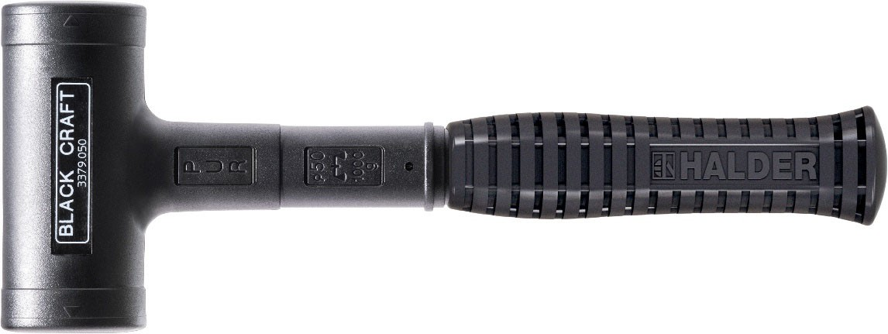
The non-rebound and fully encased BLACKCRAFT mallet from Halder …
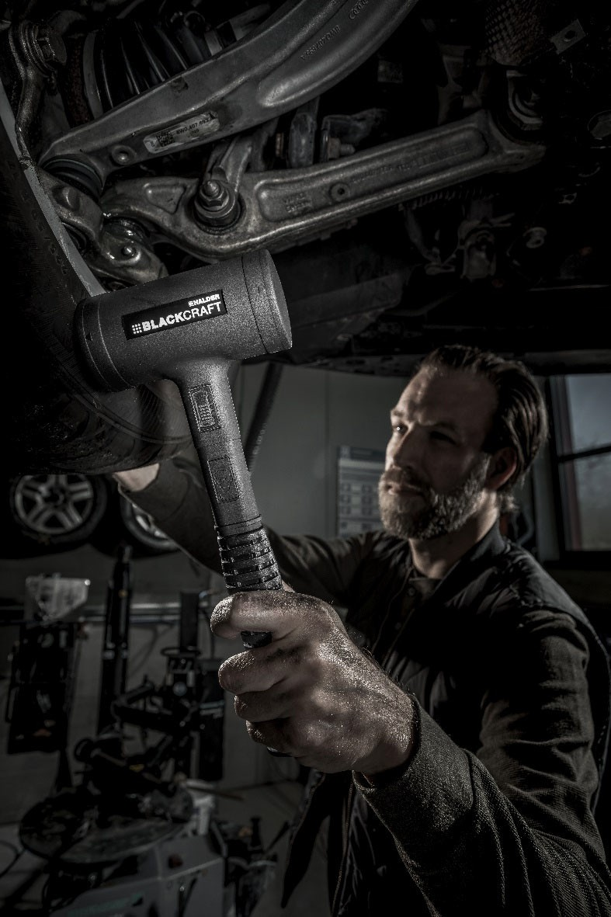
… lets you detach stuck tires from the hub in a manner that is quick and gentle on the rim.

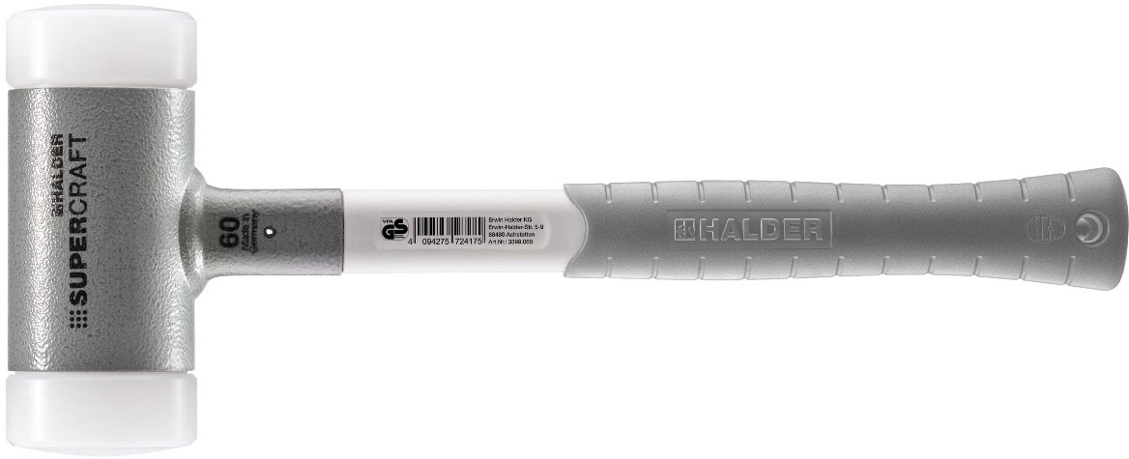
The non-rebound SUPERCRAFT soft-face mallet with 3-component handle …
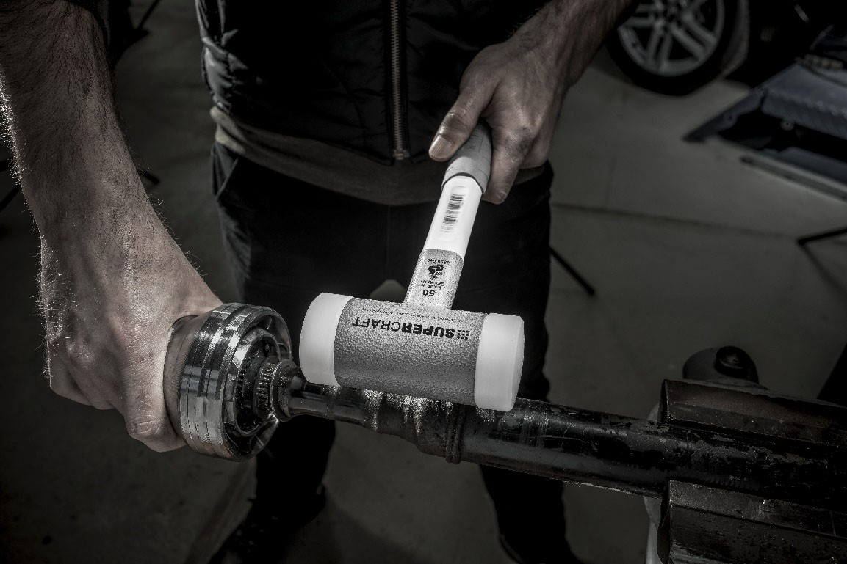
… stays securely in your hand – even with oil-smeared fingers.

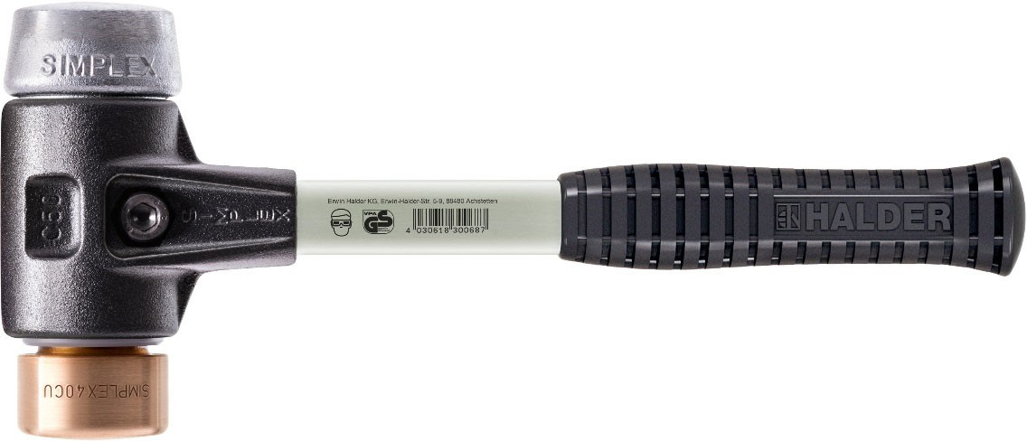
The SIMPLEX soft-face mallet with the insert combination of copper / soft metal …
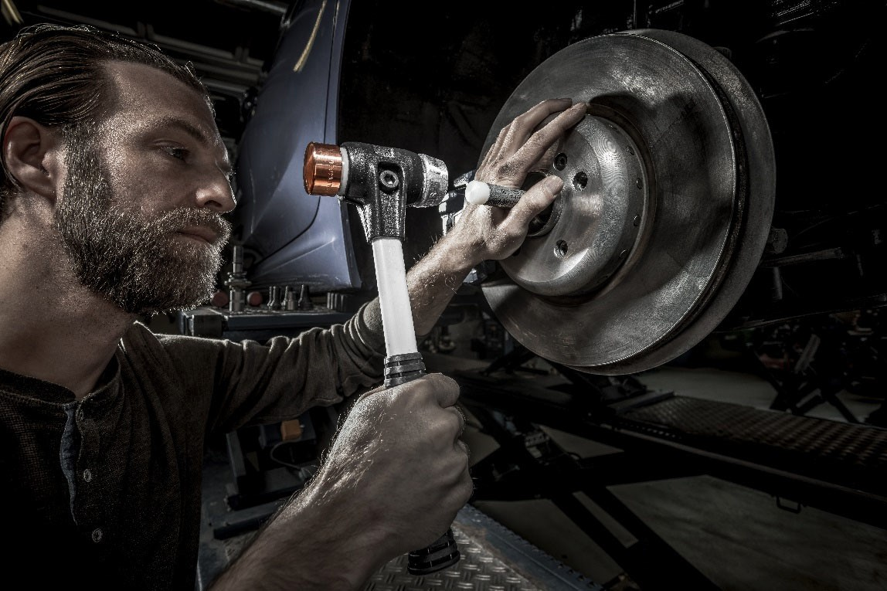
… offers a 2-in-1 solution for a variety of tasks.

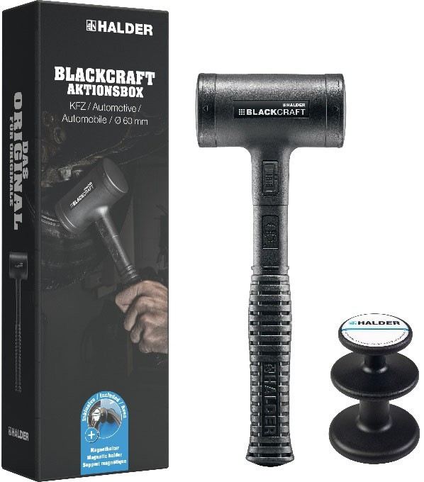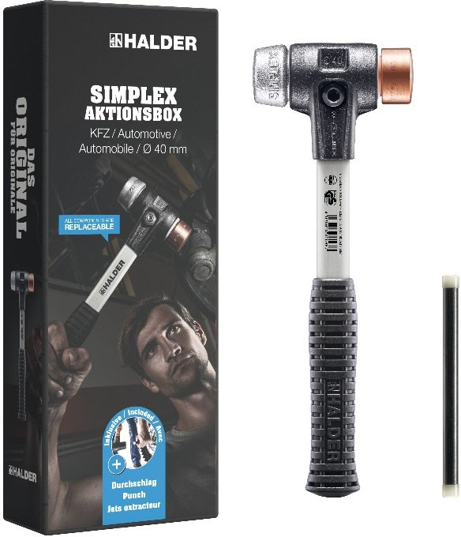

Perfect for automotive workshops: Halder Promotional Box Automotive with BLACKCRAFT or SIMPLEX.
Photos: Erwin Halder KG

Meta-Data:

Meta-Title
High-quality soft-face mallets from Halder for efficient automotive repairs and maintenance work

Meta-Description
The premium-quality soft-face mallets from Halder offer ideal solutions for the various requirements and tasks encountered in automotive workshops. BLACKCRAFT, SUPERCRAFT and SIMPLEX boost efficiency and safety during maintenance and repairs on passenger vehicles and lorries.

Tags / Keywords
Halder, Erwin Halder KG, soft-face mallets, automotive workshop, maintenance work, repair work, BLACKCRAFT, SUPERCRAFT, SIMPLEX, tire change, tool, efficiency, safety, rim-friendly.

Product ID no.: 508_8186
Pages: 9
Number of characters: 2258
Released for publication until:

About Erwin Halder KG
In 1938, Erwin Halder began production of the SIMPLEX soft-face mallet, laying the foundation for the success the company enjoys around the world today with branches in Germany, France, Slovenia, South Korea, Japan and the United States. At the head office in Achstetten-Bronnen alone the company employs a staff of around 220, while the global workforce has reached over 400. The fate of Erwin Halder KG is currently controlled by Stefan Halder, representing the third generation of the family. Family-owned and operated, the company attaches supreme importance to peerless quality in all of their product segments. The company is in full control of the entire process chain – from development to production to global distribution.
The joint product range offered by Erwin Halder KG and Picard GmbH allows the Halder Group to provide the world’s most comprehensive selection of striking tools. Apart from soft-face mallets and forestry tools, Halder also produces and sells high-precision standard parts, modular fixture systems for clamping workpieces as well as aviation products. Conforming to DIN/ISO and factory standards, the product selection comprises roughly 12,000 standard parts including machine and fixture components, clamping elements, operating elements and machine elements. What is more, Erwin Halder KG is certified for production in compliance with aviation industry standards according to EN 9100:2016. The company's global clientele includes both local craftsmen and corporations operating in the high-tech industry. In addition to offering a standard selection, the company also possesses the expertise and experience necessary to tailor customised solutions to their customers’ specific needs.

Learn more about Erwin Halder KG
at www.halder.com/de and follow us
on Facebook at www.facebook.com/HalderNormteile/ and www.facebook.com/HalderHandwerkzeuge/
on LinkedIn at linkedin.com/company/erwin-halder-kg
on XING at www.xing.com/companies/erwinhalderkg
on YouTube at www.youtube.com/channel/UC5h_MbtpB4gOfI7T2lxq77w
on Instagram at https://www.instagram.com/haldertools/

Press contact:
KSKOMM GmbH & Co. KG
Jahnstraße 13
56235 Ransbach-Baumbach
Germany
Tel.: +49 2623 7990160
E-mail: info@kskomm.de
URL: www.kskomm.de

